System Analysis and Design

PROJECT Proposal
Shefayatuj Johara Chowdhury
Lecturer
Department of CSE
Bangladesh University Of Business and Technology
Rupnagar,Mirpur-1216,
Dhaka.
Prepared For:

Prepared By:

Yeasir Ibna Hasibur Rahman
Student
Bangladesh University Of Business and Technology

Bangladesh University of Business and Technology


Project Proposal

Course Title : System Analysis and Design Lab
Course Code : CSE-318
Report On : Proposal for SmartTask – A Daily Task Reminder

Submitted By:  MD.Jahidul Islam Shihab  ID: 20234103347  Al Nasir Uddin Siam  ID: 20234103349  Munim Halder  ID: 20234103351  Yeasir Ibna Hasibur Rahman  ID: 20234103358  Intake : 52  Section: 09  Program: B.Sc. Engg. in CSE | Submitted To:  Name: Shefayatuj Johara Chowdhury  Designation: Lecturer  Department of CSE  Bangladesh University of Business and Technology

Project Proposal

Project Title: SmartTask – A Daily Task Reminder
- Introduction
Managing daily tasks effectively is essential for productivity. This project aims to create a web-based Daily Task Planner that lets users schedule their tasks and get notified on time. The software will save tasks in a MySQL database and provide functionalities to view, edit, and delete tasks. Recurring tasks etc will also be supported.

- Problem Statement :
1.Users often forget important daily tasks due to lack of reminders.
- Most existing apps are either too complex or cluttered.
- Simple apps lack useful features like task repetition or alerts.
- Manual task tracking wastes time and causes disorganization.
- There's a need for a lightweight, efficient, and user-friendly reminder system.

3. Objectives:
- Provide a simple web-based interface to add, schedule, edit, delete, and manage recurring tasks.
- Send timely reminders to users for their scheduled tasks.
- Maintain a persistent task list stored securely in a database for easy access anytime.

4. Functionalities:
- Add Task: Input task name and time.
- View Tasks: Display tasks in a list with status.
- Edit/Delete Task: Update or remove tasks.
- Recurring Tasks: Set tasks to repeat daily.
- Reminder Alerts: Notify users on task time.
- Data Persistence: Store all tasks in MySQL.
5. Implementation Details:
The system will be based on a classic web application architecture:
- Frontend: HTML forms for task input, tables to display tasks, and buttons for editing/deleting.
- Backend: PHP handles CRUD operations for tasks and serves pages.
- Database: MySQL stores task details including name, time, status, and recurrence.
- Reminder/Notification: PHP script with time comparison logic paired with JavaScript for front-end notifications.

6. Agile Model:
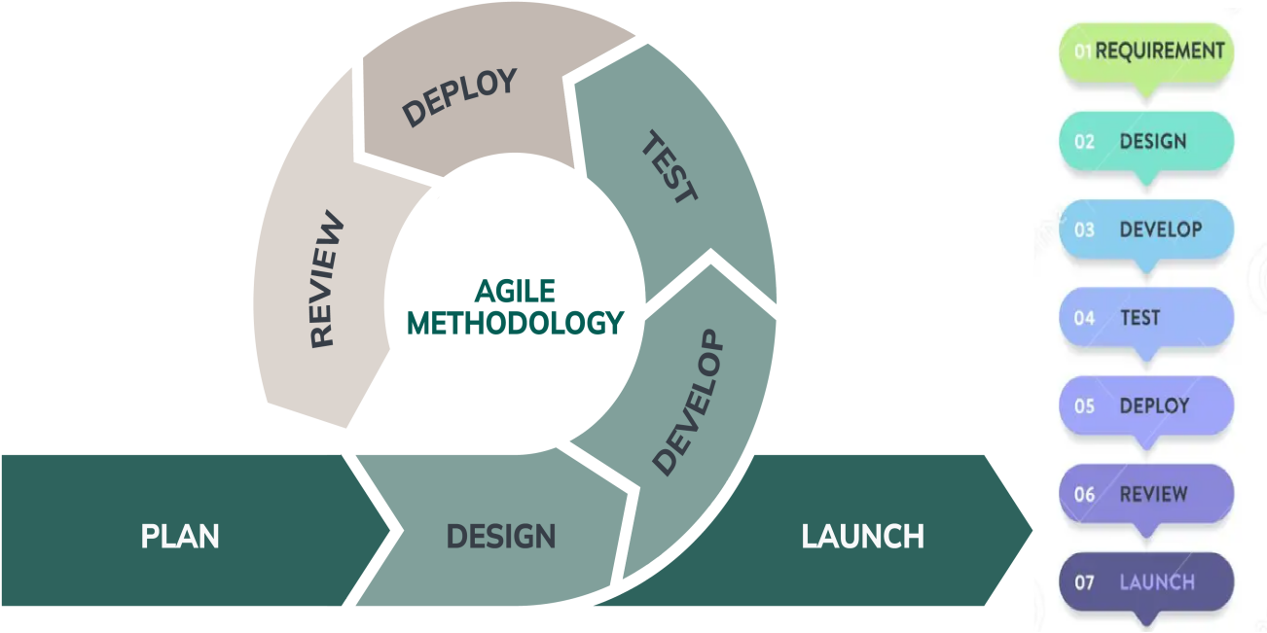
Agile Model Justification:
- Flexible and adapts to changing requirements
- Encourages frequent customer collaboration and feedback
- Delivers working software quickly in short iterations
- Identifies and reduces risks early
- Improves product quality through continuous testing
- Empowers teams to be productive and self-organized
- Provides transparency and progress visibility

7. Expected Outcome / Conclusion:
- Users will be able to easily add, edit, and delete their daily tasks through a simple interface.
- The system will send timely reminders so users don’t miss important tasks.
- All tasks will be safely saved, ensuring no data loss after closing or restarting the app.
- Recurring tasks can be set up to repeat daily, making routine management easier.
- Being a web app, users can access their tasks from any device with an internet connection.
- The project will provide a good foundation for adding more features in the future, like user accounts or better notifications.
- Overall, it will help users manage their time better and stay organized.
- This project will also help us improve our programming, database, and web development skills.

